**IDEATHON - 2020**

PES UNIVERSITY - DEPARTMENT OF COMPUTER SCIENCE AND ENGINEERING

**01** ​**PERSONAL DETAILS**

Team Name: Project Oxygen

Team Leader: YATHISH N V

Team members:

* Name: YATHISH N V
* SRN: PES1020180462
* SEM: 5th
* Email:yathishnv27@gmail.com
* Contact Number: 9538198724
* Name: Mahanash Kumar
* SRN: PES10201802050
* SEM: 5th
* Email: mahanashmetalfab@gmail.com
* Contact Number: 9113991367
* Name: Narshima
* SRN: PES10201800625
* SEM: 5th
* Email: jwalapuramnarasimha@gmail.com
* Contact Number: 7624944185

**02** ​**EXECUTIVE SUMMARY**

Theme: Smart solutions of Waste water and Air quality.

As today, in this fast-growing world, human greediness has caused ecological imbalance in the environments and due to that natural calamities like floods (currently active), earthquakes occurred and will be occurring again and again. So the main causes are cut down of trees and air pollution (global warming) and others are humans’ activities like mining, industrial exploitation, etc.

Since it is high time to bring smart solutions for this,

We have conducted the survey before we came up with solution, to analyse various parameters that is required for air quality and water quality .

First analysis is calculation of Green percentage of areas of Bengaluru and using computer vision predicting top 10 greeneries in Bengaluru.

Project Link to analysis by Yathish N V: <https://bangaloregreeneries.000webhostapp.com/>

Here, we found the green percentage of every area in Bengaluru which is considered as Garden city of India has very low percent that falls in the range of [5-38] percentage. Trees are reducing day by day, due to housing and layouts increase with high population density, there by creating air pollution. Air pollution has caused serious health issues for people. So there is need to increase greenery for environmental sustainability in Bengaluru and requirement of air quality monitoring system to create awareness among people.

Another survey by Mahanash Kumar:

Theme: Lake Rejuvenation.

Well, we took a case of a lake named Hombalammana Kere located in Magadi, which is 50 Km Bengaluru city. Hombalammana Kere has a very great historical background and was established in the year 1521 which has been proof for many dynasties like the Vijayanagara dynasty, the Yelanka dynasty which arose there.

Hombalamma lake roughly rectangular spanning 136.68 m in width and 315 m in length, covering an area of 6.139 acres/2.48 hectares. It is situated next to a paddy field and opposite to the Kempegowda fort adjacent to M.K road. So the problem arises as sewage contaminants from the 200 houses nearby are let into the lake which causes algal growth, water quality deterioration, Nutrient enrichment henceforth leading to eutrophication and degradation of the quality of the lake.

This also caused issues with the neighbors, as it leads to the accumulation and release of H2S causing the pungent odor, reduced oxygen amount leads to a decline in the aquatic population. Also, lead to an acceleration in the rate of mosquito breeding and an increase in the rate of mosquito-borne diseases.

The following water quality analysis was carried out at the Centre for Ecological Sciences dept. lab of IISc

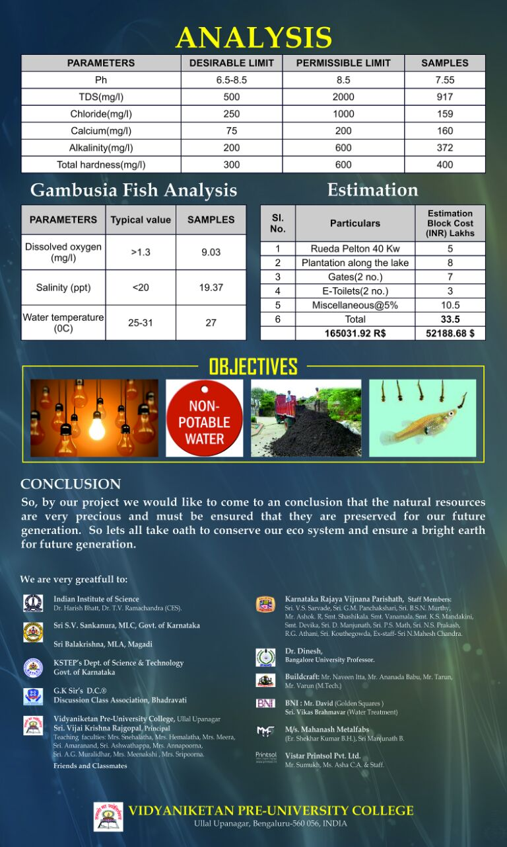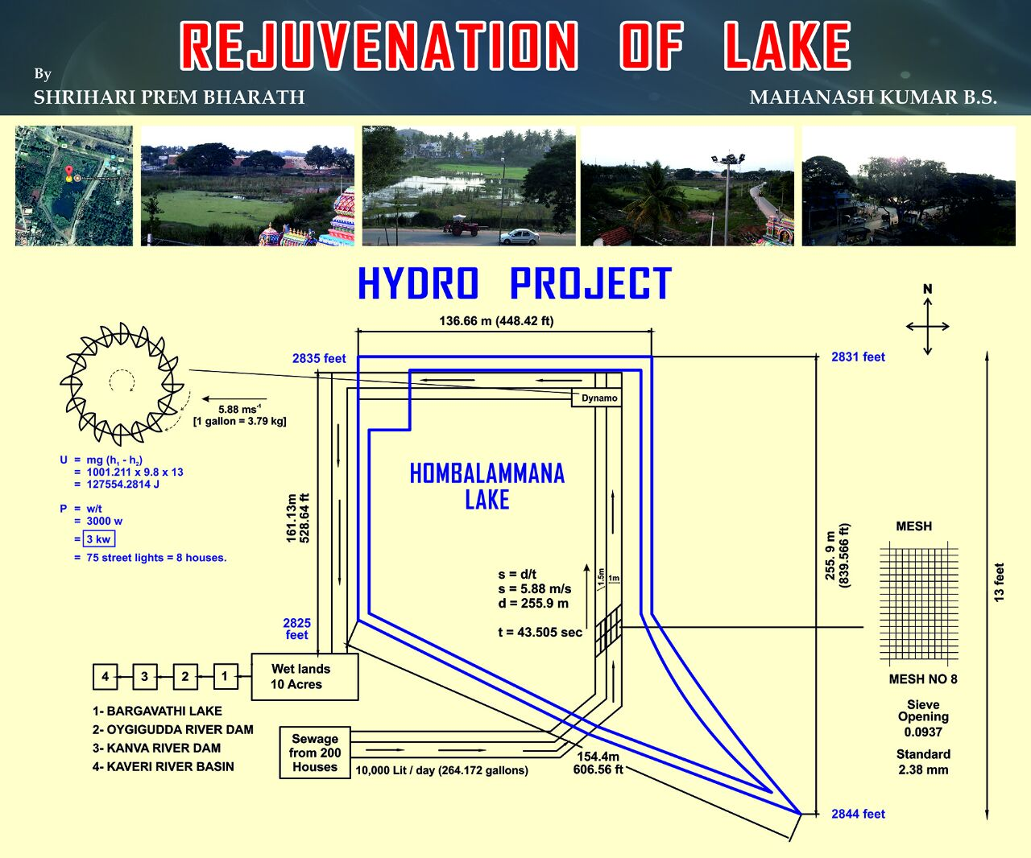

Report of survey:

As per the research based on United States Geological Survey (USGS) , The total volume of water on Earth is estimated at 1.386 billion km³ (333 million cubic miles), with 97.5% being salt water and 2.5% being fresh water and lakes are one of the most important source. Sewage contamination is one of the major reasons for lake degradation. The study, conducted by Bengaluru based Environmental Management and Policy Research Institute (EMPRI) categorised 85 per cent of existing water bodies in Bengaluru under the lowest grade which can only be used for irrigation and industrial cooling.

The topography around the lake provided altitude difference of 13 feet. The plan was to divert primary treated sewage water from the lake and eventually generate electricity. Through this approach 25 KW of electricity can be generated everyday which accounts to around 775 KW of electricity for 1 month and 9300 KW for 1 year.

The sewage water used for electricity generation can also be treated by Constructed Wetlands. The amount of Total suspended solids (TSS), total dissolved solids (TDS), biochemical oxygen demand (BOD5), chemical oxygen demand (COD), phosphorus, ammonia, and nitrites will be significantly reduced on treatment with Constructed Wetlands as per the research paper “Escherichia coli counts The Efficacy of a Tropical Constructed Wetland for Treating Wastewater During the Dry Season: The Kenyan Experience” by Springer Publication. Hence non-potable water is obtained.

Solution:

Our approach to solve the problem of waste water is to build the smart waste water management since it has lot of benefits as per survey.

Smart system of measurement of water quality index and analysing the data obtained by various areas in Bengaluru and predicting dissolved oxygen(COD),pH ,salinity and amount of nutrients and also toxic substances which are very important. Our aim is build IoT device which does the job. Pictorial representation is given here:

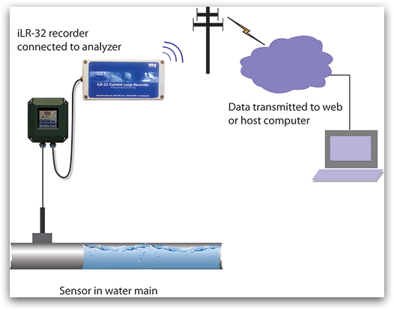

So we developed a solution to address two major problems, which were:

1. Degradation of Lake

2. The treatment of sewage water

The idea was to incorporate multiple technologies together in a single system so that a complete solution could be provided that can decontaminate the site economically in a time-efficient manner as well as improve the quality of the site through restoration.

Nano-Bioremediation method was incorporated for remediating lake as It has several advantages over physicochemical methods such as high selectivity, specificity, cost and energy efficiency, minimal requirement, etc. And the limitations encountered in Bioremediations were not seen, as there is an application of Nanotechnology which has a high removal efficiency, less time period, and is a highly efficient process. Hence Nano-bioremediation exploits the benefits of nanotechnology together with the advantages of bioremediation.

Nanoscale zerovalent iron (nZVI) has shown enormous potential in contaminant reduction and can be successfully used in groundwater remediation either through direct injection or through permeable reactive barriers (PRBs). So, the incorporation of microbial strains in nZVI helps in more efficient remediation of pollutants. Chlorinated aliphatic hydrocarbons (CAH) are recalcitrant compounds which can neither be removed completely by nZVI nor organochlorine respiring bacteria (ORB). Koenig et al. (2016) combined both the technologies for removal of CAHs and showed that at the appropriate dosage, a wide range of CAHs can be treated efficiently.

Application Methods and Process

There are two ways that have been reported for the application of an integrated nano-bio process in the treatment system. The first is a sequential method wherein the contaminant is subjected to nanoparticles first and later on bioagent is added to carry out the further process. The second method is a concurrent or combined method where both nanoparticle and biological agents are added to the system simultaneously.

For the concurrent method, there has to be a biofilm formation on the surface of the nanoparticle by the bacteria. So the computational analysis can be done in order to determine the structural configuration of the nanoparticle and select a suitable bacteria for it

Smart solutions to increase Air quality:

Our approach is to build IoT based Air quality monitoring system and ways to implement Air quality system in Bengaluru.

Harmful and toxic gases such as carbon monoxide (CO), nitrogen monoxide (NO), Nitrogen Dioxide, etc. can cause serious health problems. IoT based gas monitoring systems can help in monitoring the indoor air quality using various gas sensors. Wireless sensor networks based IoT devices can identify the hazardous zones, so that corrective measures can be taken to ensure proper ventilation.

Papers:

A hybrid sensor system for indoor air quality monitoring [IEEE International Conference on Distributed Computing in Sensor System, 2013]-> presented a hybrid sensor system for indoor air quality monitoring which contains both stationary sensor and mobile sensors.

Indoor air quality monitoring using wireless sensor network [International Conference on Sensing Technology, 2012] -> provided a wireless solution for indoor air quality monitoring that measures the environmental parameters like temperature, humidity, gaseous pollutants, aerosol and particulate matter to determine the indoor air quality.

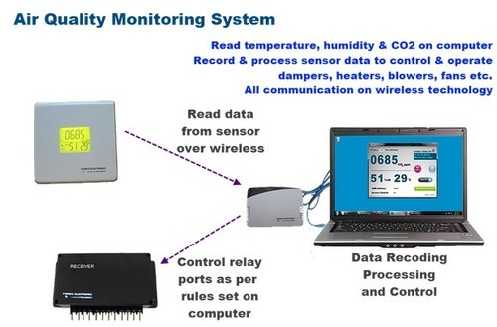

As a part of smart cities project of Govt. of India.Govt. should consider poor air quality index as a serious problem and should implement smart solutions to it.

Our method is to build these air quality monitoring system at every regions of Bengaluru and display it like one that is already in present in central town hall and make sure all the vehicles have emission test must be checked regularly by traffic police and creating awareness to the people by sending the air quality index and reviews and insights through the mobile application and also as survey shown green percentage is very less in Bengaluru, one of the method is to regulations of ban certain pollutants and increase planting of trees smartly by making strict implementation of planting trees/garden by every households. Since we are facing Covid 19 pandemic so maintaining good health is important hereby there is a need of balanced ecosystem with pure oxygen. Hence right time to implement these rules.

Finally making these systems as small scale kit and provide it to users i.e people and marketing the product built by us.

**03** ​**MARKET RESEARCH**.

There are many companies that provide these services either as NGOs or as Govt. funded projects or as initiatives like

### [Green Solutions (India) Private Limited](https://www.indiamart.com/green-solutions-india-private-limited/aboutus.html)

### [Green Solutions Ltd. | Renewable Energy Services](https://www.greensolutionsjo.com/)

### [Go Green Solutions Pvt. Ltd. – For better world](https://www.gogreensol.com/)

### [This provides a sanitizer tunnel for covid protection and waste management system but does not provide air quality system which is a added bonus to our project.](https://www.gogreensol.com/)

[Customers here is State Government for implementation of these ideas in Bengaluru and also companies that make Iot devices and systems. Industries is our major target because they emit lot of air pollutants and cause also water pollution. So strict rules must be undertaken by them and must use our end product as one of the methodology. Sewage treatment industries and manufacturing companies are also our clients . It is for the betterment of people mainly with current technology and provide these smart system chips at low cost and in effective manner. Expansion of users can be done through advertisements and promotion through social media and third party application.](https://www.indiamart.com/green-solutions-india-private-limited/aboutus.html)

**04** ​**EMPATHY MAPPING**

Clients uses the smart phone application that has been built by us as the end output and market of smart system built by us for the people to buy. Features of the app are:

●Smart phone application of which has measurement of air quality and water quality index, insights and ways to improve in app and development kit built by us which check both air quality and water quality must be brought by the customer.

● Users must follow the application periodically and implement the solutions and report any errors and also provide feedbacks and suggestions and report faulty systems.

● Usage of non-portable water and video recording will be provided of these methods must be carefully viewed by users and follow and buy the kit built by us and implement it.

● Keeping current situation in mind, users feels it is the right way and high time to implement these as precautionary measures to prevent diseases especially Covid 19 and percentage of online usage has increased most of the audiences are connected and would undertake anything that is trendy now-a-days.

**05** ​**FEASIBILITY**

Since there is heavy rainfall in everywhere, by this people get updated with weather conditions as well as air quality index and insights of various aspects and be very precautious with water management and waste management as good sanitation is required now to prevent the attack of diseases. Hence it is feasible to implement. We are still in developing stage improvement willbe done as we proceed further and further. Important for us it to be economical and effective with precision and accuracy.

* Cost structure would the installation cost of the these iot systems at the government level requires Crores together of funding.
* In fracture for making large implementation.
* Chip cost (large scale),maintaince cost and application database management cost and cost also depends on the end users, labour cost,etc.
* Dynamic cost.

**06** ​**DEPLOYMENT**

Smart IoT based solution with mobile application communication used for deployment of our idea.

1. Small scale implementation of IoT system and testing.
2. Building Smart phone application
3. Publishing in play store.
4. Testing the application.
5. Presentation of idea and prototype to Government of India.
6. Contacting Electronic companies for building these Iot system.
7. Industrial level partnership for smart solutions
8. Setup of start-up with BMC, handling investments and revenues.
9. Large scale implementation of smart solutions.
10. Maintenance and expansion of the system.

THANK YOU